P-4.3 An ideal D-to-C converter produces an output signal whose $\hat{ω}$ frequency content is the same as the input signal’s discrete-time frequency content over the range $-π≤\hat{ω}≤π.$ However, the continuous-time frequency axis (ω) is a scaled version of $\hat{ω}$. For each of the discrete-time signals y[n] below, determine the continuous-time output signal y(t) from an ideal D-to-C converter whose sampling rate is fs = 3600 Hz.
(a) $y[n] = 8 cos(0.6πn - π/3)$
(b) $y[n] = 4 cos(1.2πn - π/4)$
(c) $y[n] = 2 cos(2.4πn - π/5)$

$$Discrete Time Frequency:\hat{ω}=\frac{2πf_{0}}{f_{s}}→$$
$$0.6π=\frac{2πf_{0}}{3600}→f_{0}=1080, thus ω=2π*1080=2160π$$
$$Thusly, the Continous-time signal is:y\left(t\right)=8*\cos\left(2160πt-\frac{π}{3}\right)$$
$$Discrete Time Frequency:\hat{ω}=\frac{2πf_{0}}{f_{s}}→$$
$$1.2π=\frac{2πf_{0}}{3600}→f_{0}=2160, thus ω=2π*2160=4320π$$
$$Thusly, the Continous-time signal is:y\left(t\right)=4*\cos\left(4320πt-\frac{π}{4}\right)$$
$$Discrete Time Frequency:\hat{ω}=\frac{2πf_{0}}{f_{s}}→$$
$$2.4π=\frac{2πf_{0}}{3600}→f_{0}=4320, thus ω=2π*4320=8640π$$
$$Thusly, the Continous-time signal is:y\left(t\right)=2*\cos\left(8640πt-\frac{π}{5}\right)$$

P-4.4 The spectrum diagram, which gives the frequency content of a continuous-time signal, helps in determining the Nyquist rate for sampling that signal.
$$Trig Identity: \cos\left(θ_{1}\right)\cos\left(θ_{2}\right)=\frac{1}{2}\left(\cos\left(θ_{1}+θ_{2}\right)+\cos\left(θ_{1}-θ_{2}\right)\right)$$
(a) Given the signal $x(t) = cos(4000πt) cos(8000πt)$, draw a sketch of its spectrum. Label the frequencies and complex amplitudes of each component spectral line.
(b) Determine the minimum sampling rate that can be used to sample x(t) without aliasing for any of its components.
(c) Given the signal $r(t) = cos(3×{10}^{6}πt)sin(5×{10}^{6}πt)cos(7×{10}^{6}πt)$, determine the minimum sampling rate to avoid aliasing for any of its components.
(d) Given the signal $v(t) = cos(3 × {10}^{6}πt) + sin(5 × {10}^{6}πt) + cos(7 × {10}^{6}πt)$, determine the minimum sampling rate to avoid aliasing for any of its components.

$$x\left(t\right)= cos\left(4000πt\right)cos\left(8000πt\right)→0.5\cos\left(12000πt\right)+0.5\cos\left(4000πt\right)→$$
$$\frac{e^{j\left(12000πt\right)}+e^{-j\left(12000πt\right)}}{4}+\frac{e^{j\left(4000πt\right)}+e^{-j\left(4000πt\right)}}{4}→\frac{e^{j\left(6000*2πt\right)}}{4}+\frac{e^{-j\left(6000*2πt\right)}}{4}+\frac{e^{j\left(2000*2πt\right)}}{4}+\frac{e^{-j\left(2000*2πt\right)}}{4}$$
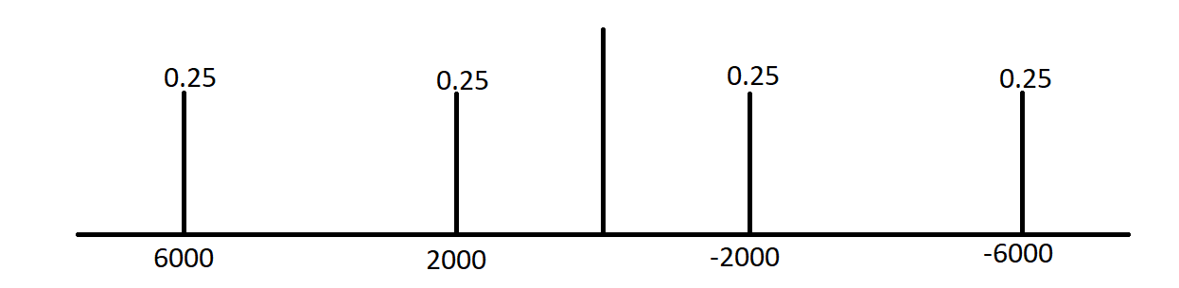
Due to the maximum frequency being 6000 Hz, as demonstrated by $x\left(t\right)=0.5\cos\left(12000πt\right)+0.5\cos\left(4000πt\right)$, it is already known that the minimum sampling rate for a signal must be twice its frequency, thus the sampling rate will be 12000 Hz.
$$r\left(t\right)= cos\left(3×{10}^{6}πt\right)sin\left(5×{10}^{6}πt\right)cos\left(7×{10}^{6}πt\right)→cos\left(3×{10}^{6}πt\right)cos\left(\frac{π}{2}-5×{10}^{6}πt\right)cos(7×{10}^{6}πt)$$
$$cos\left(7×{10}^{6}πt\right)*\frac{1}{2}\left(\cos\left(\frac{π}{2}-2×{10}^{6}πt\right)+\cos\left(\frac{π}{2}-8×{10}^{6}πt\right)\right)→$$
$$\frac{1}{2}\left(\cos\left(\frac{π}{2}-2×{10}^{6}πt\right)cos\left(7×{10}^{6}πt\right)+\cos\left(\frac{π}{2}-8×{10}^{6}πt\right)cos\left(7×{10}^{6}πt\right)\right)→$$
$$\frac{1}{2}\left(\frac{1}{2}\left(\cos\left(\frac{π}{2}+5*{10}^{6}πt\right)+\cos\left(\frac{π}{2}-9*{10}^{6}πt\right)\right)+\frac{1}{2}\left(\cos\left(\frac{π}{2}-1*{10}^{6}πt\right)+\cos\left(\frac{π}{2}-15*{10}^{6}πt\right)\right)\right)→$$
$$\frac{1}{4}\cos\left(\frac{π}{2}+5*{10}^{6}πt\right)+\frac{1}{4}\cos\left(\frac{π}{2}-9*{10}^{6}πt\right)+\frac{1}{4}\cos\left(\frac{π}{2}-1*{10}^{6}πt\right)+\frac{1}{4}\cos\left(\frac{π}{2}-15*{10}^{6}πt\right)$$
After reviewing the previous equation, it can be determined that the maximum frequency will be 7.5 MHz, thus the sampling rate will be 15 MHz.
The max frequency can be seen to be 3.5 MHz, and thus the minimum sampling rate is 7 MHz
P-4.11 When the cosine waveform x(t) = 3 cos(500πt) is sampled at a rate $f_{s}$, we obtain a discrete-time signal x[n] given by
$$x\left[n\right]= x\left(\frac{n}{f_{s}}\right) = 3 cos(800πn/fs)$$
for $-∞ <n< ∞$. In the following parts, assume that fs = 3600 Hz.
(a) Determine how many samples are taken in one period of the cosine wave x(t). This answer is the average number of samples per period, which is an integer in this case.
(b) Now consider another cosine waveform y(t) with a different frequency ω0
$$y(t) = 3 cos(ω0t)$$
Find a value for ω0, between 7000π and 9999π rad/s, such that the signal samples are identical to x[n] above, that is, $y[n] = y\left(\frac{n}{f_{s}}\right) = x\left(\frac{n}{f_{s}}\right)$ for all n. Hint: The solution involves aliasing.

The frequency of the input signal is 250 Hz, and thus the samples per period is: $\frac{f_{s}}{f_{max}}=\frac{3600}{250}≅15 samples per period$

$$\hat{ω_{0}}=2mπ+\frac{800π}{f_{s}}→ω_{0}=2mπf_{s}+800π$$
$$ω_{0}=2mπ*3600+800π$$
$$7000π<ω_{0}<9999π→0.86<m<1.28$$
$$substituting m with 1 results in ω_{0}=8000π rad/s$$

P-4.15 Suppose that a discrete-time signal x[n] is given by the formula
$$x[n] = 7 cos(0.7πn + 0.2π )$$
and that it was obtained by sampling a continuous-time signal at a sampling rate of $fs=\frac{1}{Ts}=8000$samples/s.
(a) Determine two different continuous-time signals x1(t) and x2(t) whose samples are equal to x[n]; in other words, find x1(t) and x2(t) such that $x[n] = x_{1}(nT_{s}) = x_{2}\left(nT_{s}\right)$ if $T_{s} = 125μs$. Both of these signals should have a frequency less than 8000 Hz. Give a formula for each signal.
(b) If x[n] is given by the equation above, what signal is reconstructed by an ideal D-to-C converter operating at sampling rate of 5000 samples/s? That is, determine the output y(t) in Fig. 4-21 when the sampling rates are different.

$$\hat{ω}=\frac{ω}{f_{s}}→0.7π=\frac{2πf_{1}}{8000}→f_{1}=2.8 kHz.$$
$$x_{1}\left(t\right)=7\cos\left(2πf_{1}t+0.2π\right)→7\cos\left(5600πt+0.2π\right)$$
$$7 cos\left(2π-1.3πn+ 0.2π \right)→7 cos\left(1.3πn-0.2π \right)$$
$$\hat{ω}=\frac{ω}{f_{s}}→1.3π=\frac{2πf_{1}}{8000}→f_{1}=5.2 kHz.$$
$$x_{2}\left(t\right)=7\cos\left(2πf_{1}t-0.2π\right)→7\cos\left(10400πt-0.2π\right)$$

$$\hat{ω}=\frac{ω}{f_{s}}→0.7π=\frac{ω}{5000}→ω=3500π\frac{rad}{s}$$
$$y\left(t\right)=7\cos\left(3500πt+0.2π\right)$$

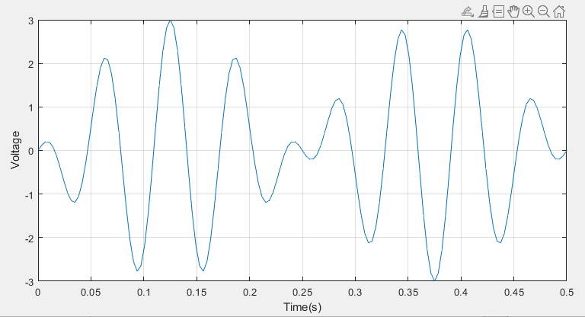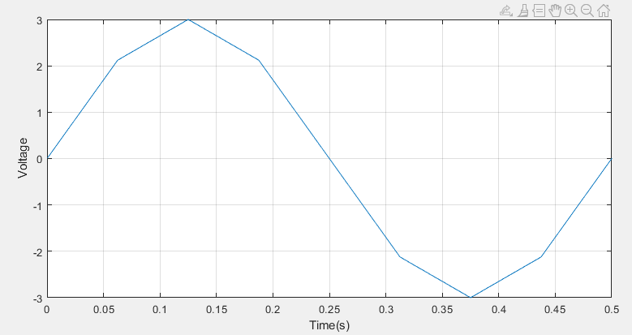

MATLAB Code:
clc; clear; close all;
fs=0.5;%range of plot
n=288;%sampling rate
t = 0:1/n:fs;
signal=3*cos(2*pi*16*t).*sin(2*pi*2*t);
plot(t, signal);
xlabel('Time(s)');
ylabel('Voltage');
grid on;

